Skills Lab

Physiology Lab Supplement

Pulse Oximeter:

Pulse oximetry is a non-invasive means of measuring oxygen saturation of arterial blood. Oxygen saturation is defined as the amount of hemoglobin that is bound to O₂ divided by the amount of total hemoglobin that is available to bind with O₂. Pulse oximetry has become widely accepted as a means of measuring O₂ saturation. It uses two wavelengths of light to measure the saturation of oxygen. The lights shine through the vascular bed and measure the saturation via a probe. Probe placements include: thumb, finger, bridge of nose, ear and for children the foot and hand. No calibration is required for the equipment. Pulse oximeters have been helpful in reducing the number of arterial blood gases (ABG’s). They are also very useful in assessing trends and/or rapid changes in oxygen saturations.

Errors in Pulse Oximeter Measurements:

Improper probe placement – low numbers
Motion Artifacts – low numbers
Hypothermia (decreased perfusion) – low numbers
Vasopressor drugs (vasoconstriction) – low numbers
Stray ambient light (sun light, bili light) – low numbers
Low Light transmissions (edema, dark skin, nail polish, nail coverings) – low numbers
Dyshemoglobin concentrations (carboxyhemoglobin, methemoglobin) – high numbers

When there is a correlation between pulse oximeter heart rate and cardiac monitor heart rate the accuracy of the pulse oximeter is + 2%. Advantages to pulse oximeters are rapid response, non-invasive, and accuracy.

Oxyhemoglobin Dissociation Curve:

The curve shows the relationship of plasma oxygen partial pressure to the degree of which potential oxygen-carrying hemoglobin sites have oxygen attached.

PO₂ (mmHg) | Saturation (%)
27 | 50 %
40 | 75 % (mixed venous)
60 | 90 %
97 | 97 %
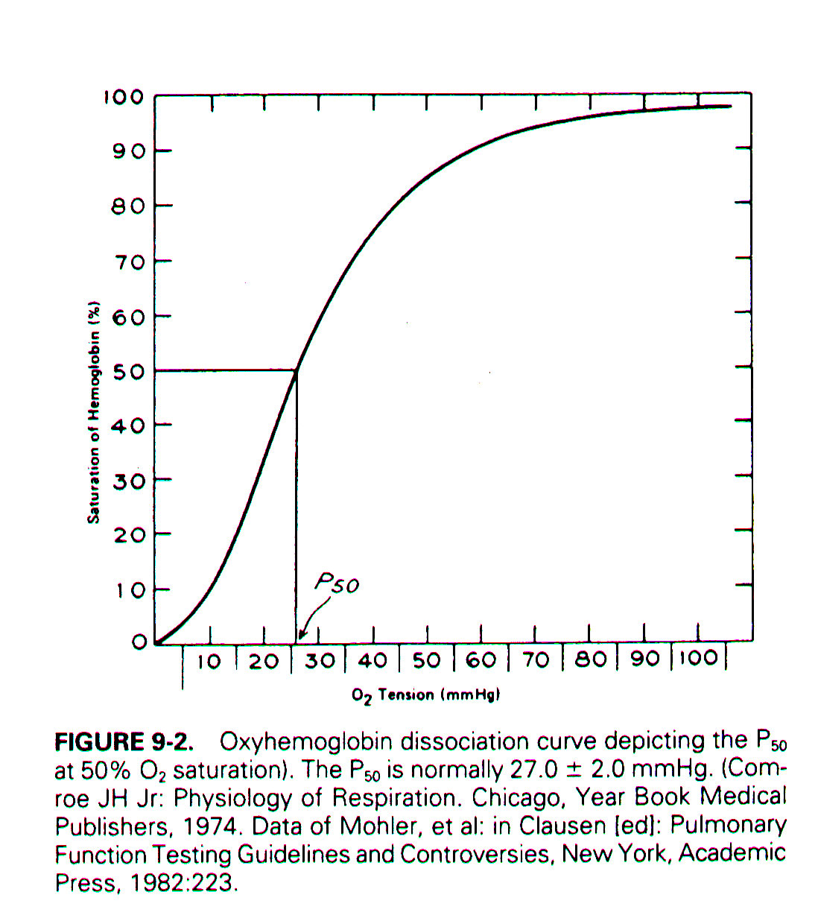
The hemoglobin curve allows you to assess the affinity for oxygen. Increase O₂ affinity (shift-left) means a higher O₂ content at any given PO₂. Conversely, decreased O₂ affinity (shift- right) means a lower O₂ content at any given PO₂.

Shift Left – alkalemia, hypothermia, hypocarbia, and decreased 2,3-DPG.
Shift Right – acidemia, hyperthermia, hypercarbia, and increased 2,3-DPG.

Cardiac Monitoring: (ECG Monitor)

Initiation of cardiac monitoring is a very important step in the treatment of a patient. Most monitors are cardiopulmonary monitors, this allows the medical team to assess the patient in multiple ways (i.e. EKG, pulse, pulse oximetery, respiratory rate, blood pressure, & etc.) and displays all information in a central location.

Applying electrodes:
Expose the chest (always respect privacy) and prep skin for lead placement.

Skin Preparation:
- Shave excessive hair at electrode site.
- Oily skin and/or diaphoretic - clean skin with alcohol pad and let dry.
- Attach lead wires to electrodes.
- Apply leads to patient chest.
EKG Lead Colors codes: (Normally)
White – Right arm
Black – Left arm
Red – Left leg
Always remember to turn alarms on and set limits.

Einthoven’s Triangle

ECG electrode placement for leads I, II and III.

Three Basic “Law” of Electrocardiography

- A positive (upward) deflection appears in any lead if the wave of depolarization headed in the direction of the positive pole of the lead.
- A negative (downward) deflection appears in any lead if the wave of depolarization is headed in the direction of the negative pole of the lead,
- When the mean depolarization path is directed at right angles (perpendicular) to any lead, a small biphasic deflection (consisting of positive and negative deflections of equal size) is usually seen.

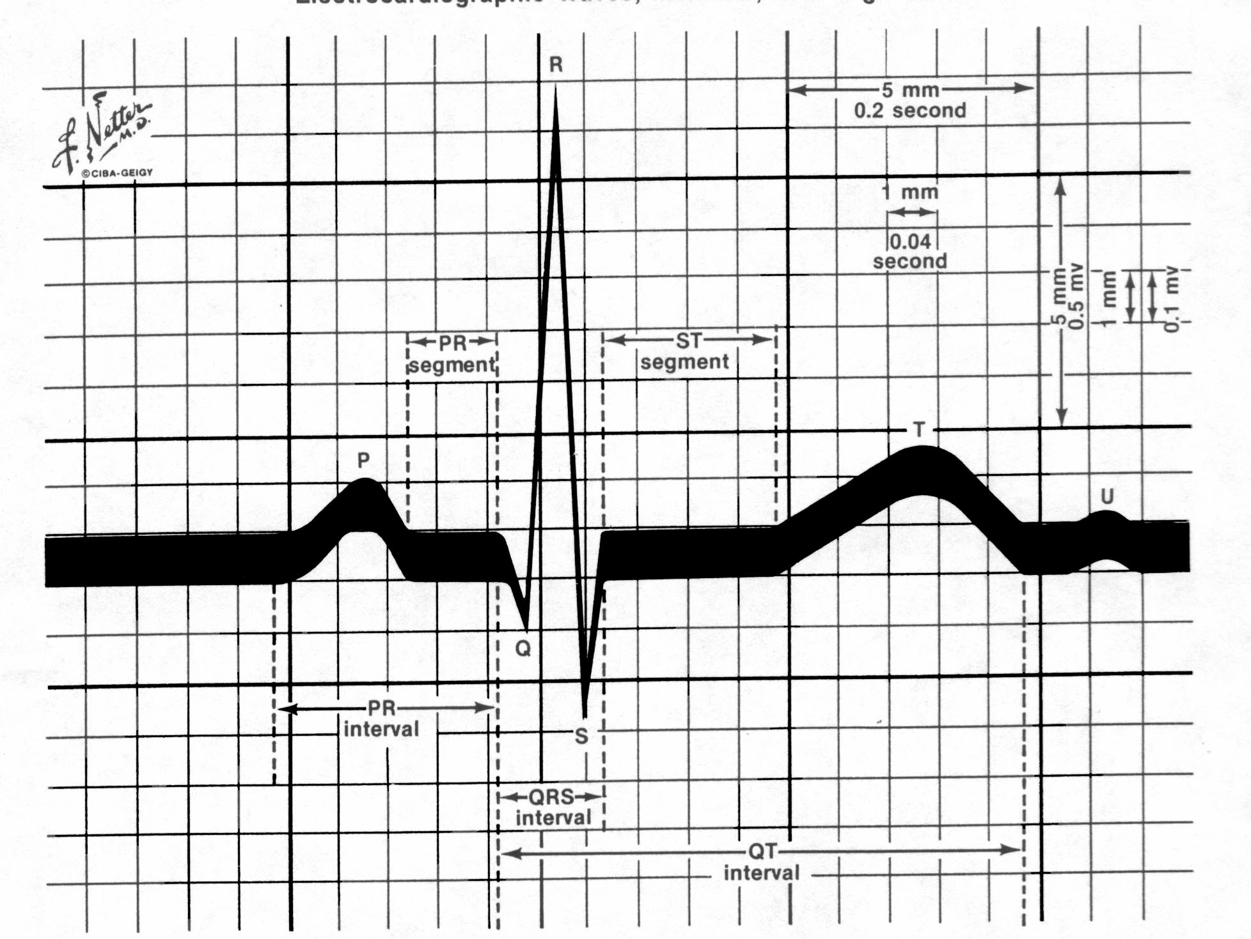

Keeping these three laws in mind, all you need to know is what lead the ECG is displaying and you can predict how the P waves and the QRS complexes will appear.

P wave: atrial depolarization; is the first waveform seen in the cardiac cycle. It is always positive in lead II.
PR interval: represents the time it takes for the stimulus to spread through the atria and pass through the AV junction.
QRS Complex: Ventricular depolarization.
ST Segment: early phase of ventricular repolarization.
T wave: Ventricular repolarization.
U wave: rounded deflection sometimes seen after the T wave. It represents the last phase of ventricular repolarization.

Assessing Heart Rate
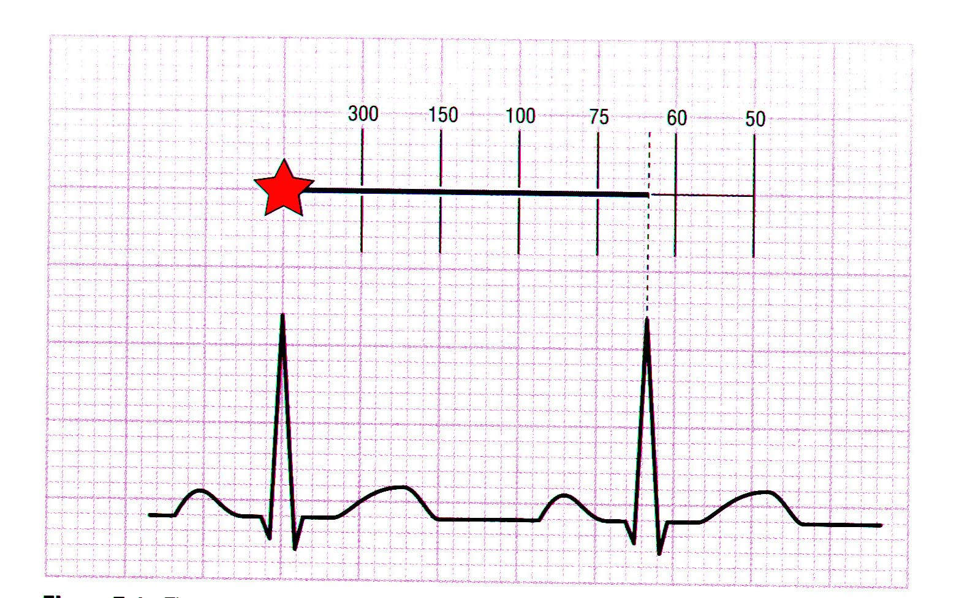
Normal Sinus

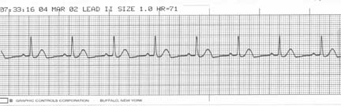

Sinus Arrhythmia

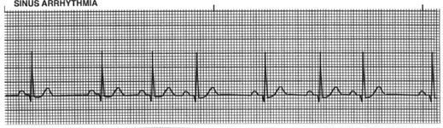

Sinus Brady

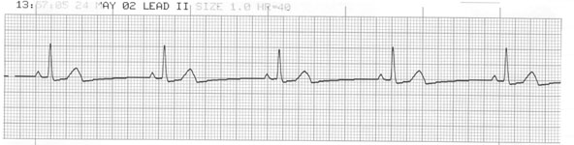

Sinus Tachycadia

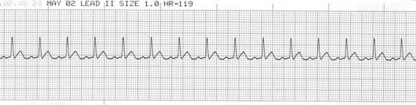

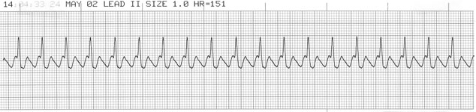
Atrial Flutter

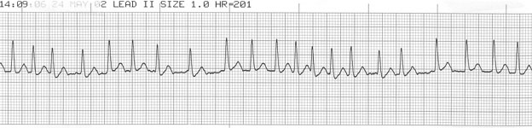
Atrial Fibrillation

Ventricular Tachycardia (V-Tach)
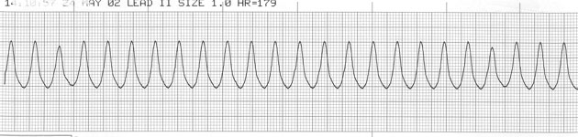

Ventricular Fibrillation (V-Fib)

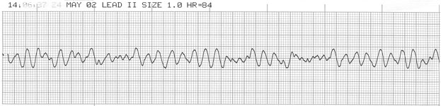

Reference:
- Garcia, T. & Holtz, N. (2001) 12-Lead ECG The Art of Interpretation. Massachusetts; Jones and Barlett.
- Goldberger, A. (1999) Clinical Electrocoardiography: A Simplified Approach (6th Edition); Massachusetts; Mosby.

